Isaac Asimov Presents the Best Horror and Supernatural of the 19th Century, Beaufort Books 1983 Stated First Edition. First Print with full print line. As new, no chips or marks, unclipped dust jacket price $16.95 in mylar. As new hard cover with all 368 pages tightly bound and no marks of any kind. Cover art Jay J. Smith 8vo. ISBN 0825301289
Terrific anthology of 25 stories from Washington Irving, J. Sheridan LeFanu, Edgar Allan Poe, Bram Stoker, Arthur Conan Doyle, and many others.
ID 000324 Price $35 Box 5

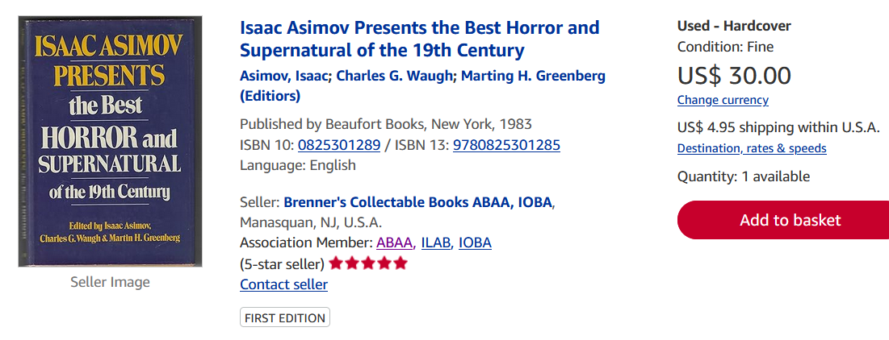
AbeBooks $7 to $59

